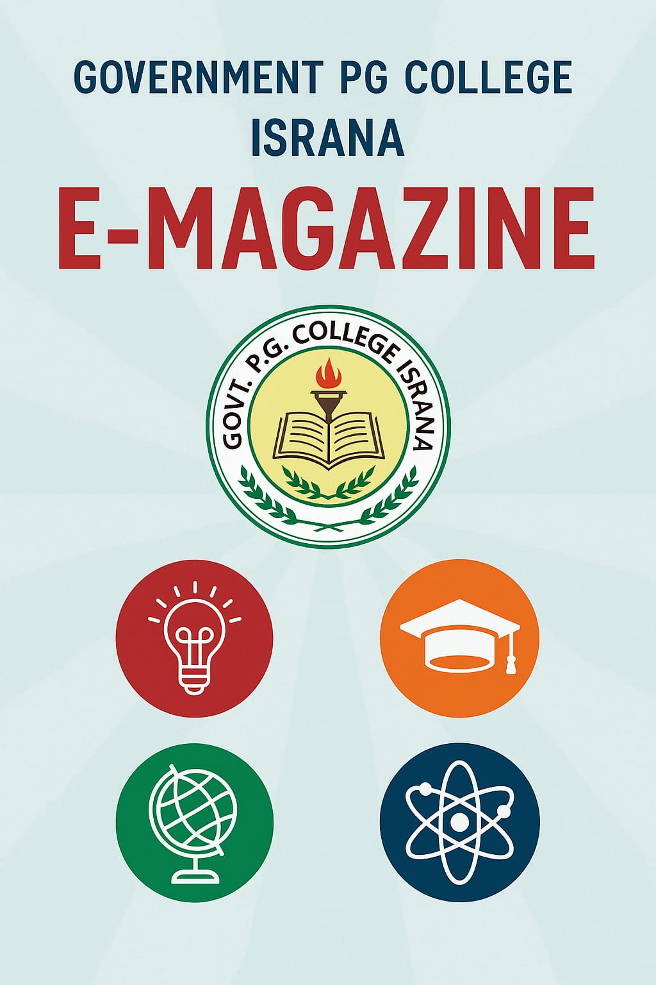

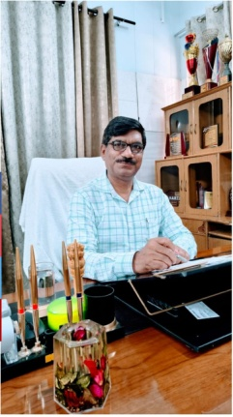
Dr. Hari Om
Principal
As Principal of Government PG College Israna I (Dr Hari Om) am honored to lead an institution committed to academic excellence, personal growth, and societal impact. Our vision is to be a transformative educational beacon, fostering intellectual curiosity, innovation, and holistic development to prepare students as ethical, adaptable global citizens ready to tackle dynamic challenges. The aim of this institution is to create an inclusive, vibrant learning community that blends academic rigor with practical skills; ensuring graduates excel in their fields and contribute meaningfully to society. The education as more than just classes—it’s a lifelong adventure. Institution creates a friendly, creative, and caring environment where every student can shine. Our approach combines great teaching with activities outside the classroom to help students think critically, understand different cultures, and care about others. The college value fairness, sustainability, and new ideas, and we work to meet the needs of our community and the world. Our teachers and staff are dedicated to creating a place where everyone can learn; feel included, and become strong leaders. The college makes sure that no student may left behind because of money or other challenges. Through partnerships with businesses and organizations, this institution offer real-world opportunities to prepare students for good careers and meaningful lives. The whole staff of this college encourages our students to love learning, respect the world, and help to build a better future.

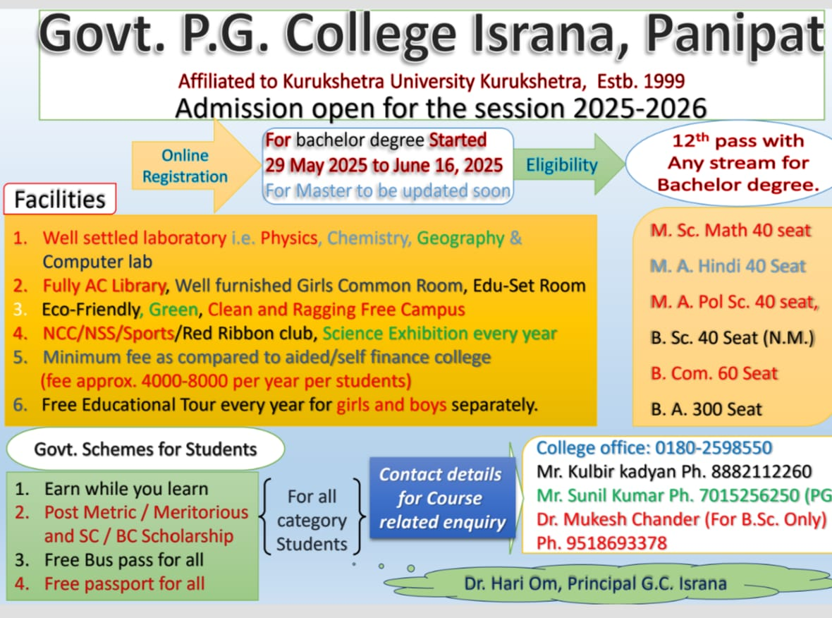

Student Support and Welfare:

- An orientation programme for newly admitted students was organized on 22/08/2024, where IQAC and faculty members guided them about curriculum, facilities, scholarships, and extracurricular opportunities.
Placement cell:
Sr. No | Name Of Activity | Date | Photo
01 | 7 days workshop on “Interview Skills And CV Preparation” | 24-09-2024 to 30-9-2024 | 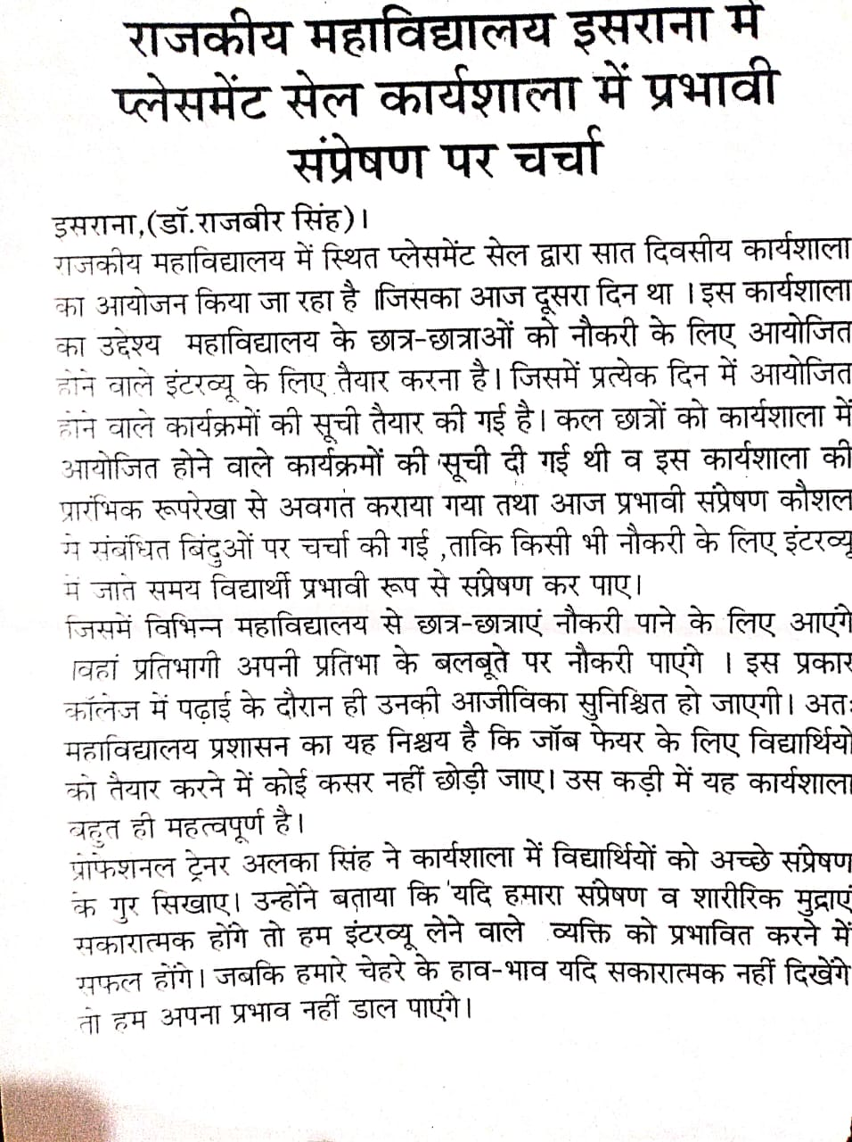
02 | A Motivational Lecture by Work Bharti Foundation | 30-9-2024 | 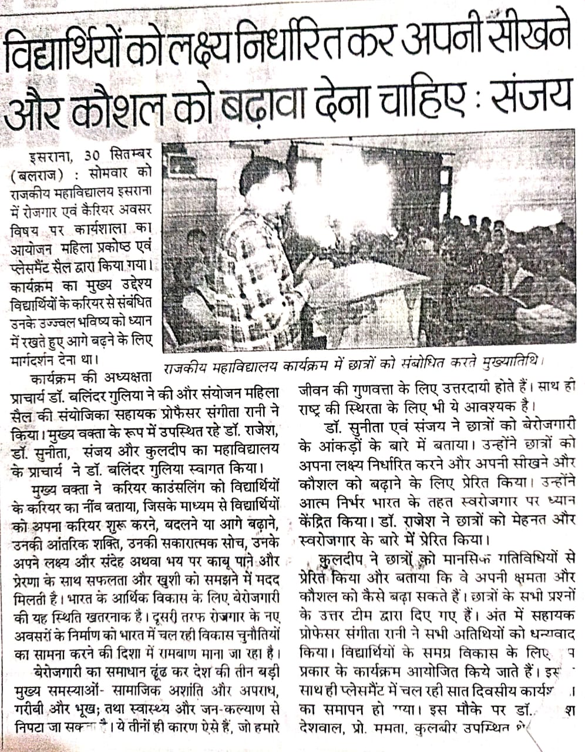
03. | Best Out Of Waste Competition | 18-02-2025 | 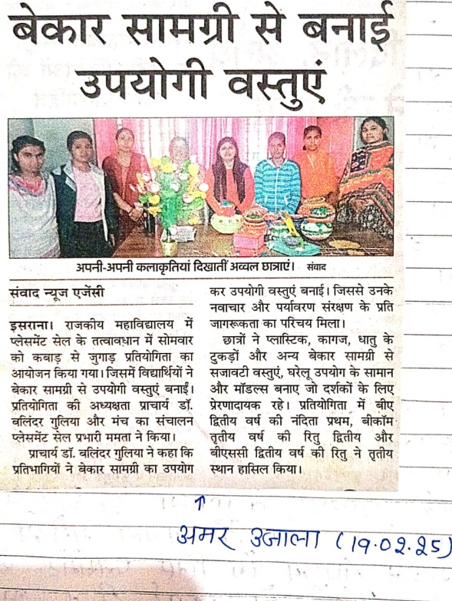
04. | Extension lecture on Placement In Banks | 18-04-2025 | 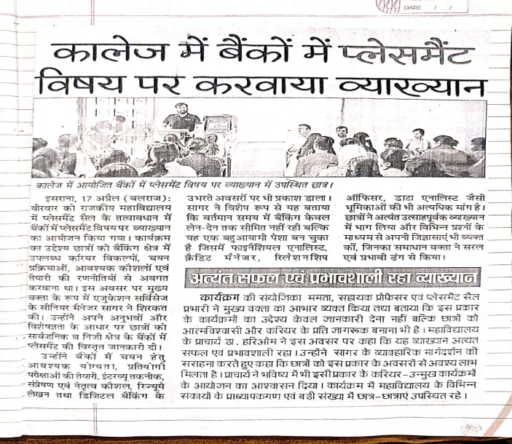
05 | Extension lecture on “Career Opportunity In Indian Army” |  | 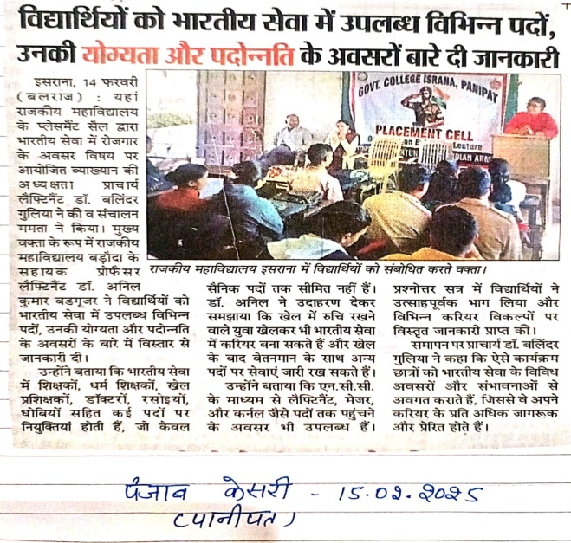
Women Cell:
Sr.No. | Name of activity | Date | Objective
1 | A seminar organized on the theme of “drug free India” on the occasion of international Youth Day | 13 -08-24 | To empower and mobilize the youth of India as proactive agents of change in building a drug-free society, by equipping them with knowledge, resilience, and a sense of collective responsibility.  To achieve the main goal, the seminar would focus on these specific, actionable objectives:  - Awareness and Education  - Prevention and Resilience Building  - Pathway to Support and Rehabilitation
2 | Organized Women's Health and Hygiene Awareness Campaigning cum Induction Program | 04-09-24 | To empower women with essential knowledge and resources to take control of their health and hygiene.  1.Educate: To provide clear information on crucial health & hygiene topics.  2. Break Stigma: To create a comfortable space for open discussion and questions.  3. Promote Prevention: To encourage regular check-ups and healthy habits for early detection of issues.
3 | Matka Decoration Competition | 18-09-24 | To empower women by providing a creative platform for artistic expression, fostering a sense of community, and celebrating traditional Indian craftsmanship.
4 | A Lecture on Career Opportunities | 24-09-24 | To inform and guide students about the diverse career paths, eligibility criteria, and application processes for both teaching and non-teaching positions at Government College, Israna, thereby preparing them for future opportunities at the institution.
5 | Workshop on Career and Employment Opportunities | 30-09-24 | To empower job seekers with the tools to plan their career and secure a job.  What the workshop will do  1. Explore: Identify various career paths and in-demand job roles.  2. Develop: Teach essential skills like resume writing, interview techniques, and LinkedIn profiling.  3. Navigate: Provide strategies for effective job searching and application processes.  4. Bridge: Connect the gap between academic qualifications and industry requirements.
6 | Mehndi competition on the occasion of Navratri | 09-10-24 | To celebrate the artistic talent, cultural heritage, and festive spirit of Navratri through the traditional art of Mehndi.
7 | Seminar on Mental Health Awareness and a Drug-Free India | 19-09-24 | To promote mental well-being as a cornerstone of a healthy society and empower the community with knowledge and strategies to prevent drug abuse, fostering a collective movement towards a Drug-Free India.
8 | A campaign on women's health and hygiene awareness | 11-02-25 | To empower women with essential knowledge and resources about health and hygiene, enabling them to make informed decisions and improve their overall well-being.

- Internal Complaint Committee (ICC) functioned actively to ensure compliance with The Sexual Harassment of Women at Workplace (Prevention, Prohibition and Redressal) Act, 2013 and UGC guidelines. The committee worked towards creating a safe, gender-sensitive campus and spreading awareness about prevention of sexual harassment.
- Constitution of Mentor Groups for better understanding of abilities and problems of the students. Mentors identify the Mentees' learning abilities on the basis of their academic performance, behaviour, social and psychological aspects during the individual interaction session in the mentorship classes.
Extension and Outreach Activities:
- The college participated in the 75th Van-Mahotsav celebration held at Karnal on 13/07/2024, where students and faculty members contributed towards spreading awareness on environmental conservation and plantation.
- The institution actively took part in the ‘Say No to Drugs and Say Yes to Life’ signature campaign on 12/08/2024, motivating students and the community to follow a healthy and drug-free lifestyle.
- Faculty, staff, and students of the college participated in the 78th Independence Day celebration at New Grain Mandi, Israna on 15/08/2024, upholding the spirit of patriotism and national integration.
- An extension lecture on “Fostering Quality Academic Research: An Essential Key Point in NEP 2020” was organized on 21/04/2025, jointly by the NEP Committee, Research Promotion Cell, and Internal Quality Assurance Cell. Faculty and students actively participated in the programme, which emphasized the importance of quality research as envisioned in NEP 2020.
- Saplings were planted in the college campus under the activity ‘Ek Ped Maa Ke Naam 1.0’, jointly organized by the NSS, Eco Club and NCC. Students from different streams actively participated in this initiative, and were sensitized about the importance of environmental health and their role in creating health-supportive environments.

Academic Achievements:
- Followed the academic calendar as provided by the KUK.
- Introduction of NEP 2020 in UG I as per Kurukshetra University guidelines. Academic Bank of Credits, Skill Enhancement Courses, Ability Enhancement Courses, Value Added Courses and Multidisciplinary Courses were introduced for UG I students.
- Teaching faculty members prepared and adhered to the Lesson Plan for their respective classes before the commencement of both semesters. Lesson plans were also displayed on the college website.

History Subject Society:
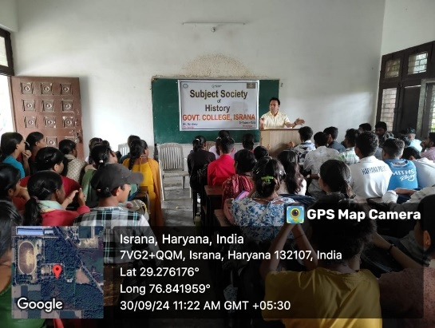
1. On the occasion of Gandhiji's birth anniversary on 30/09/2024, a Seminar/extension lecture was organized by the History Subject society on the topic. "Relevance of Gandhiji's thoughts” in the 21st century.

2. An Essay writing competition on the topic "आधुनिक विश्व के उदय में पुनर्जागरण की भूमिका" was organised by the History Subject society on 14th October 2024.

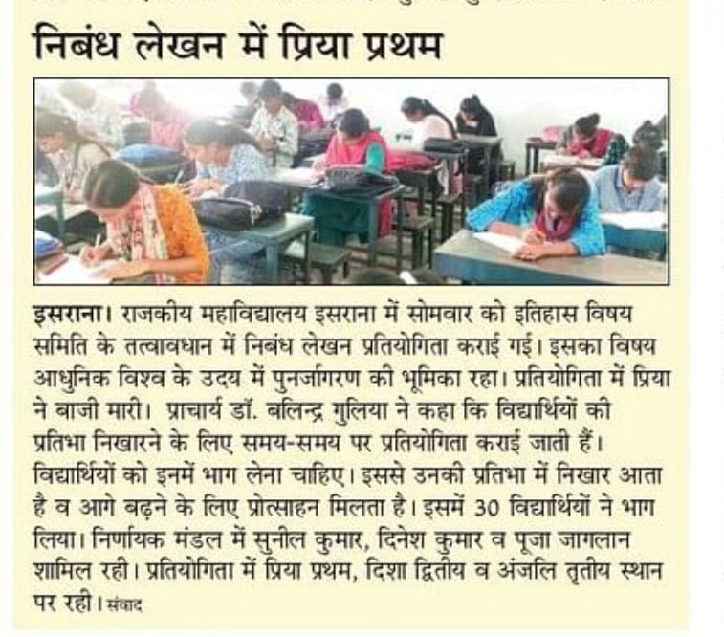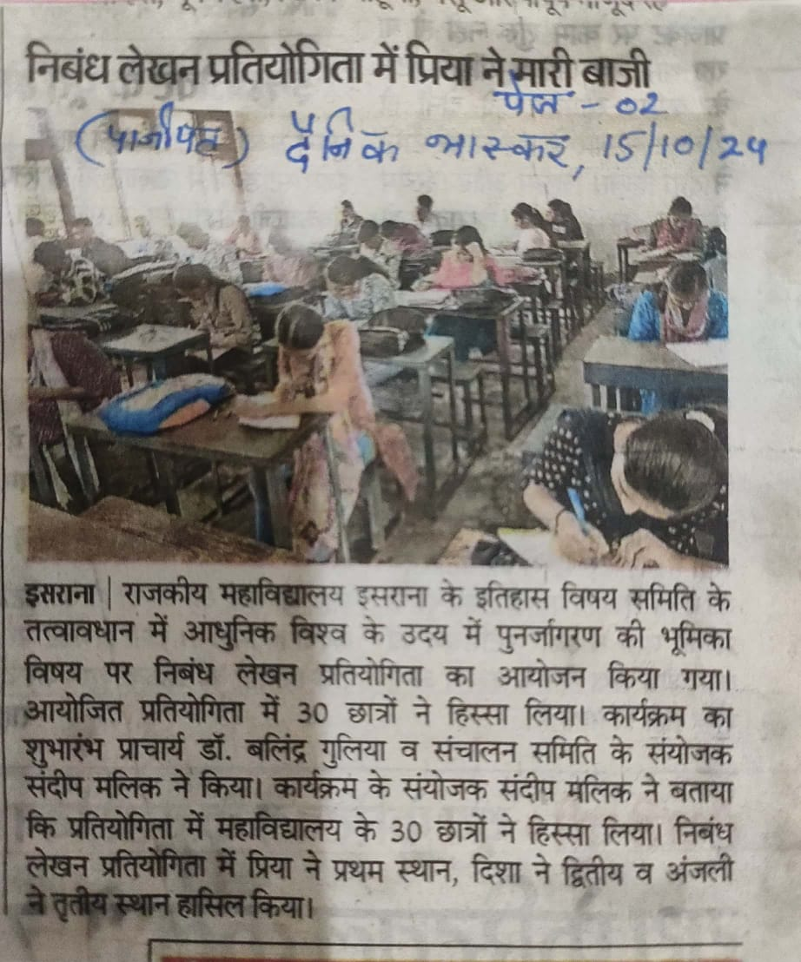

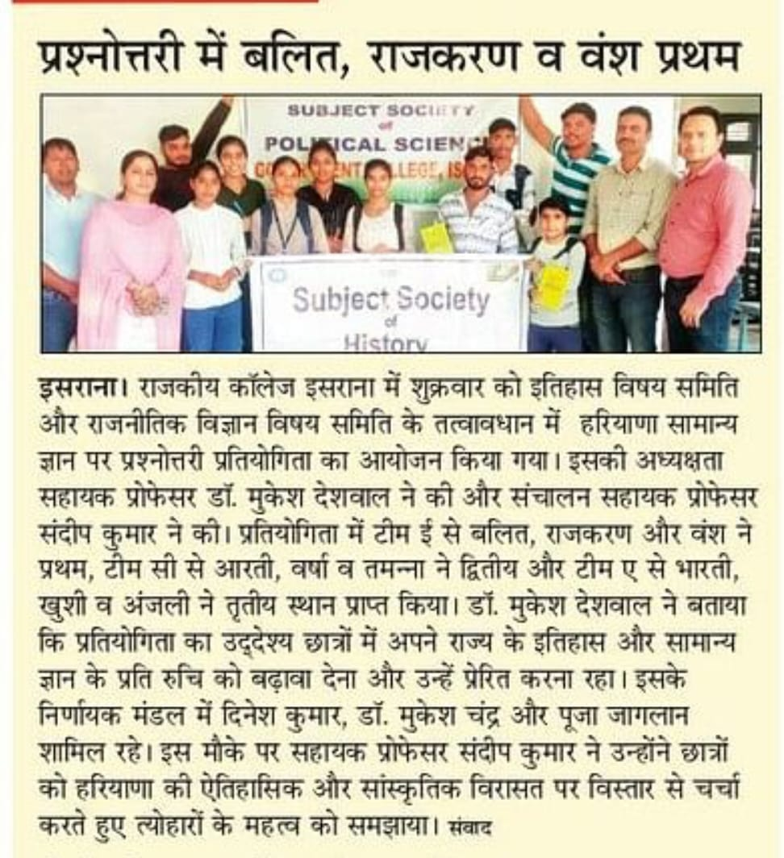
3. On the occasion of Diwali and Haryana Day a quiz competition on Haryana General Knowledge was organised under the joint aegis of History Subject Society and Political Subject Society on 25/10/2024.

Dr. Reeti Gupta (Assistant Professor of Commerce)
- Gupta, R. (2024). Mobile wallets growth and financial literacy. In R. P. Meena (Ed.), Crisis to opportunity: Navigating the current landscape of finance and entrepreneurship (pp. 85-94). Himalaya Publishing House. ISBN: 978-93-6557-181-3
- Gupta, R. (2024). Dynamics of family-work conflict among women academicians. In R. P. Meena (Ed.), Crisis to opportunity: Navigating the current landscape of finance and entrepreneurship (pp. 175-193). Himalaya Publishing House. ISBN: 978-93-6557 181-3
- Gupta, R., Jain, A., & Singh, K. (2025). AI-Driven Sustainable Business in CSR Reporting Regime: A Systematic Literature Review. In E. Shaikh (Ed.), Corporate Social Responsibility Approaches to Ethical AI in Business (pp. 277-292). IGI Global Scientific Publishing. ISBN: 979-8-3693-3478-2. DOI: https://doi.org/10.4018/979-8 3693-3478-2.ch015
- Gupta, R. (2025). Women-led green entrepreneurship: Motivators and challenges. Journal Global Values, XVI (Suppl. 1), 136-142. May. ISSN (P): 0976-9447 (e):2454 8391. DOI: https://doi.org/10.31995/jgv.2025.v16iSI.022

Dr. Prateek Mor (Assistant Professor of Mathematics)
- Quantum codes obtained through (v) -Constacyclic codes over Z_3 +v Z_3, Journal of Xidian University, 18(10), 801-807, 2024. (Scopus, UGC). Dr Anup Singh, Sangita Yadav, Dr Balveer Singh, Dr Prateek Mor
- Quantum codes obtained through Constacyclic codes over Finite Ring, Journal of Xidian University, 19(2), 202-211, 2025. (Scopus, UGC). Sangita Yadav, Dr Balveer Singh, Dr Prateek Mor
- Attended and presented a paper entitled "Quantum codes obtained through (v) -Constacyclic codes over Z3+ Z3" in International Conference on Mathematical Innovations and Applications: MATHTECH-2024, organized by Department of Mathematics, Chaudhary Bansi Lal University, Prem Nagar, Bhiwan from January 17-18, 2025.
- Some convergence results using a new implicit iteration process in CAT(0) space, International Journal of Nonlinear Analysis and Applications, 1-6, 2024. (Scopus, ESCI). Prateek Mor, Sangita Yadav, Anju Panwar, Pinki Lamba
- Participated in and successfully completed the International Workshop on Learning Science with Fun: A Way Forward towards Experiential Learning (LSFEL) organized by Department of Physics, Chaudhary Bansi Lal University, Bhiwani from February 3 - 4, 2025.
Dr. Kulbir Kadyan (Assistant Professor of Chemistry)
- Kadyan K., Singh R., Sindhu J., Kumar P., Devi M., Lal S., Kumar A., Singh D., Kumar H. (2025) Exploring the structural versatility and dynamic behavior of Acyl/aroyl hydrazones: A comprehensive review. Topics in current chemistry, 383, 2, 1-67, http://dx.doi.org/10.1007/s41061-025-00503-1.
- Presented paper in national conference “Role of NSS in nation building: challenges and opportunities” on 29 march 2025 at S.D. P.G. College Panipat.
Presented Paper in national conference “Sustainable solutions for a greener future” on 08 February 2025 at GCW Rohtak.
Presented research paper in international conference “innovations in Science & Technology for Viksit Bharat” on 21-22 March 2025 at Arya P.G. College Panipat.
Dr. Parveen Kumar (Assistant Professor of Geography)
- Refresher Course on Research Methodology (ID) under Malaviya Mission Teacher Training Programme (MM-TTP) of University Grant Commission (UGC) organized by UGC- MMTTC, Guru Ghasidas Vishwavidyalaya (A Central University), Bilaspur (CG) from 05-08-2024 to 19-08-2024 and Obtained Grade A Grade.
Mr. Sandeep (Assistant Professor of History)
i) Orientation/ Refresher Course:
- Successfully completed two-week online Refresher Course on 'Indian Management System' (Multidisciplinary) organised by Malaviya Mission Teacher Training Centre. Bhagat Phool Singh Mahila Vishwavidyalaya, Khanpur Kalan, Sonepat, Haryana from 11th December to 24th December 2024.
Faculty Development Programme /Workshops:
- Successfully completed a one-week online workshop on 'NEP Orientation & Sensitization Programme’ organised by Malaviya Mission Teacher Training centre, Kurukshetra University, Kurukshetra, from 18th Nov. 2024 to 30th Nov 2024.
- Attend a one-day workshop on ‘राष्ट्रिय शिक्षा नीति 2020: सुझाव से समाधान’ at Govt PG college Ambala Cant. on 07/01/2025.
- Attended one day workshop on "Preventing and Addressing Sexual Harassment in HEls" on 18th March, 2025 at Kurukshetra University, Kurukshetra.
Presented in Seminars/webinar/Conferences:
- Presented a research paper titled "The Role of Community and Peer Support in Enhancing Student well-being" in a One-day multidisciplinary Online National seminar Organised by SNRL Jairam Girls College, Lohar Mazra, Kurukshetra, sponsored by DGHE, Haryana (Panchkula) on 23rd November 2024.
- Presented a research paper titled "Ethical Challenges in Social Research Methodology" in a One-day multidisciplinary online National Seminar Organised by SNRL Jairam Girls College, Lohar Majra Kurukshetra approved by DGHE, Haryana (Panchkula) on 30th November 2024.
- Presented a research paper titled "NEP-2020 and Vocational Education: A Step Towards Skill Development” in a One-day Multidisciplinary National Seminar (Hybrid Mode) on 'NEP-2020: Relevance, Opportunities and Challenges' organised by Tau Devi Lal Govt. College for Women, Murthal, Sonepat, Haryana on 18th January, 2025.
Sh. Sunil Kumar (Assistant Professor of Political Science)
- Successfully completed two-week online Refresher Course on 'Indian Management System' (Multidisciplinary) organised by Malaviya Mission Teacher Training Centre. Bhagat Phool Singh Mahila Vishwavidyalaya, Khanpur Kalan, Sonepat, Haryana from 11th December to 24th December 2024.
- Presented a research paper titled " NEP-2020: Relevance, opportunities and Challenges" in a One-day Multidisciplinary National Seminar (Hybrid Mode) on 'NEP-2020: Relevance, Opportunities and Challenges' organised by Tau Devi Lal Govt. College for Women, Murthal, Sonepat, Haryana on 18th January, 2025.
Ms. MAMTA (Assistant Professor of Sanskrit)
- शोध पत्र - कालिदासकालीन लोक विश्वास व धारणाएँ: विशेष संदर्भ ‘अभिज्ञान शाकुन्तलम्’ International Journal of Research खंड - अंक-15 Nov 2017 ISSN 2348-6848 UGC-APPROVED Sr. No -44396
- Orientation Course: - UGC-HRDC Bhagat Phool Singh Mahila Vishwavidyalaya, Khanpur Kalau Sonipat 20-11-2018 to 18-12-2018
- Refresher course: - Pandit-Madan Mohan Malaniya National-Mission-on Teachers and training-center, Ramanujan College D.U. held from 22 Dec 2023 to 10 Jan 2024 on the topic ‘Shrimad Bhagavad Gita: Enlightenment and Relevance.’
- Ms. Mamta Presented a research paper on “Women in Vedic Era” in the National Seminar on “Viksit Bharat @2047 ke Aalok Mein Stree Vimrash” organized by Mahila Prakoshth, Uttarakhand Sanskrit Vishwavidyalaya, Haridwar on 8th March 2025.
- Ms. Mamta successfully completed a Short-Term Course on “Human Values & Well-being for All Subjects” organized by UGC–Malaviya Mission Teacher Training Centre, Banaras Hindu University, Varanasi from 8th to 14th May 2025.

Sh. Dinesh (Assistant Professor of English)

- Refresher Course in Indian Languages from UGC HRDC Panjab University 13.9.23 to 26.9.2023
- Short Term Professional Development Programme on Implementation of NEP for University and College Teachers from 23 February 03 to March 2023.
- National level online Conference on Indian writing in English Organized by I.B (P.G) College, Panipat on 23-12-2023.
- Two Days online FDP on ‘E-Content Development' organised by S.D. College, Ambala Cantt. on 29.06.2020 to 30.06.2020.
- Orientation Programme organised by CPDHE (UGC-HRDC) Delhi Univesty fam 03-07-2018 to 30-07-2018.
Dr. Anup Singh (Extension Lecturer of Mathematics)
- Singh, A., Kumari, M., & Barak, M. S., Kumar, M., (2025)."Horizontal and vertical motion at the surface of partially saturated soils layer sandwiched between water and elastic solid." Wave in Random and Complex Media. DOI: https://doi.org/10.1080/17455030.2022.2045043 http://www.tandfonline.com/
- Presented the paper. “Reflection and refraction of inhomogeneous waves at the boundary of porous solid and partially saturated mediums.” In the International Confrence on Mathematical science and Application organized by the Department of Mathematics, IGU Meerpur Rewari, Haryana during March 05, 2025.
Ms. Poonam Saini (Extension Lecturer of Commerce)
- Presented a paper entitled "NEP 2020 and its Influence on Employability, Skill Development Opportunities of students” in One Day Multidisciplinary National Seminar (Hybrid Mode) organised by Tau Devi Lal Govt. College for Women, Murthal Sonipat, Haryana on 18 January, 2025.

Co-curricular and Cultural Activities:
- A Talent Search Programme was organized on 17–18/09/2024 to provide a platform for students to showcase their skills in cultural, academic, and sports activities, thereby encouraging their holistic development.
- As per the Academic Calendar, all departments prepared the calendar for co-curricular, extracurricular, and extension activities.
- Constitution Day was celebrated on the college campus on 26/11/2024, where faculty and students actively participated in activities emphasizing the importance of constitutional values, fundamental duties, and democratic principles.
Governance and Administrative Activities:
- The College Audit was conducted by the office of the Principal Accountant General of Haryana from 11/11/2024 to 14/11/2024, where IQAC and the college administration ensured proper presentation of records, transparency, and smooth completion of the audit process.
- Annual Committees of the staff were constituted for effective management of various college activities and communicated to both teaching and non-teaching staff.

Best Practices
1. Career Guidance and Employability Enhancement
Objectives of the Practice:
- To equip students with essential skills for employability and career readiness.
- To expose students to diverse career opportunities in various sectors.
- To bridge the gap between academic learning and industry requirements.
The Placement Cell organized the following activities:
- 7-Day Workshop on “Interview Skills and CV Preparation” (24/09/2024–30/09/2024)
- Motivational Lecture by Work Bharti Foundation (30/09/2024)
- Extension Lecture on Placement in Banks (18/04/2025)
- Extension Lecture on “Career Opportunities in Indian Army” (2025)
2. Women Empowerment and Health Awareness
Objectives of the Practice:
- To empower female students through knowledge, awareness, and skill development.
- To promote health and hygiene awareness among women.
- To build confidence and resilience among young women for personal and professional growth.
The Women Cell organized the following activities:
- Seminar on “Drug Free India” (13/08/2024 – International Youth Day)
- Women’s Health and Hygiene Awareness Campaign cum Induction Programme (04/09/2024)
- Matka Decoration Competition (18/09/2024)
- Lecture on Career Opportunities (24/09/2024)
- Workshop on Career and Employment Opportunities (30/09/2024)
- Mehndi Competition on the occasion of Navratri (09/10/2024)
- Seminar on Mental Health Awareness and Drug-Free India (19/09/2024)
- Women’s Health and Hygiene Awareness Campaign (11/02/2025)

Principal
Government P.G.College,
Israna (Panipat)

